  ACTPULSE IOT PRoJECT | Abstract  An IoT-based monitoring system using ESP32 is designed to detect and report real-time ON/OFF status of critical electrical equipment such as generators, UPS systems, and computers through isolated sensors and a centralized backend platform for live tracking and operational analytics.  Benedict Nsale

Contents
Chapter 1 – Project Overview & Technical Context 3
1.1 Project Goal 3
1.2 System Scope 4
Devices Being Monitored 4
Electrical Characteristics 4
Deployment Environment 4
1.3 High-Level Technology Stack 5
Frontend 5
Backend 5
Embedded Firmware 5
Controller Hardware 5
Chapter 2 – Hardware Architecture & Design Approach 7
2.1 Hardware Design Philosophy 7
Electrical Safety 7
Modular and Replaceable Components 7
Industry-Proven Detection Components 8
Readily Available Components 8
2.2 Power Detection Methodology 8
Rationale for Voltage-Based Operational Detection 8
Relay-Based ON / OFF Detection (Primary Method) 9
Voltage Sensor Module (Secondary / Redundant Detection) 9
Event-Driven Reporting (State Change Only) 9
2.3 Hardware Signal Flow 10
Signal Flow Overview 10
Physical Isolation Between AC Mains and Microcontroller 10
Low-Voltage Operation on Controller Side 10
2.4 Controller Selection Rationale 11
ESP32 Selection Overview 11
Wi-Fi Connectivity 11
Arduino Framework Compatibility 11
GPIO and ADC Capabilities 11
Chapter 3 – System Architecture & Implementation Design 12
3.1 Overall System Architecture 12
3.1.1 Architectural Overview 12
3.1.2 End-to-End System Architecture Diagram 12
3.1.3 Architectural Characteristics 13
3.2 Edge IoT Hardware Architecture 13
3.2.1 Hardware Block-Level Architecture 13
3.2.2 Electrical Isolation Strategy 14
3.3 Detailed IoT Component Connection Diagram 14
3.3.1 AC Detection and Control Wiring Diagram 14
3.3.2 Voltage Sensor Connection (Secondary Detection) 15
3.4 Power Supply Architecture 15
3.4.1 Battery-Based Power System 15
3.4.2 Power Design Rationale 15
3.5 Data Flow and Operational Sequence 16
3.5.1 ON / OFF Event Flow 16
3.6 Summary of Chapter 3 16
3.7 – Comprehensive Electronic Circuit Design 16
3.7.1 Circuit Design Overview 16
3.7.2 ESP32 Pin Assignment Summary 17
3.7.3 High-Voltage AC Detection Circuit 17
3.7.4 AC Voltage Sensor → ESP32 ADC Circuit 18
Voltage Sensor Connections 18
3.7.5 Battery Power Supply Circuit 19
3.7.6 Common Ground Strategy (Low Voltage Only) 19
3.7.7 Optional Status LED Circuit 20
3.7.8 Complete Text-Based Circuit Diagram 21
21
3.7.9 Safety and Implementation Notes (Very Important) 21
3.7.10 Circuit Design Summary 22

Chapter 1 – Project Overview & Technical Context

1.1 Project Goal
The objective of this project is to design and deploy a reliable IoT-based hardware system capable of determining the ON / OFF operational status of critical electrical devices, specifically:
- Electrical generators
- Uninterruptible Power Supply (UPS) units
- Computer systems and related IT equipment
The system shall detect whether a monitored device is actively powered and report state transitions (ON → OFF, OFF → ON) in real time to a centralized platform.
In addition to live status visibility, the system will support long-term operational analytics, including:
- Automatic calculation of uptime (total duration the device is ON)
- Automatic calculation of downtime (total duration the device is OFF)
- Timestamped event logging for historical analysis and reporting
From a hardware perspective, the project emphasizes the following design principles:
- Non-intrusive measurement:
The monitoring system must not interfere with the normal operation of the electrical devices. Sensors shall be installed externally without modifying the internal circuitry of the monitored equipment.
- Electrical safety:
The design must ensure galvanic isolation between high-voltage AC power lines and low-voltage control electronics to minimize risk during installation and operation.
- Scalability:
The hardware design shall allow multiple devices to be monitored independently using the same architecture, enabling future expansion without redesign.
- Reliability and maintainability:
Components shall be selected based on availability, stability, and suitability for continuous operation in indoor or semi-industrial environments.
The primary function of the hardware subsystem is state detection and event reporting, not high-precision energy measurement. This simplifies sensor requirements and improves overall system robustness.

1.2 System Scope

Devices Being Monitored
The system is designed to monitor devices that draw electrical power from standard AC mains, including but not limited to:
- Standalone diesel or petrol generators
- UPS units supplying backup power to IT systems
- Desktop computers, servers, or other critical computing equipment
Each monitored device will be treated as an independent entity, identified uniquely within the system.

Electrical Characteristics
- Power Type:
Single-phase AC power
- Measurement Objective:
Presence or absence of electrical load (ON / OFF state), rather than exact voltage or power consumption values.
- Detection Methodology (High-Level):
ON/OFF status is inferred based on electrical activity (e.g., current flow), allowing safe and indirect monitoring.

Deployment Environment
The system is intended for deployment in:
- Indoor environments (server rooms, offices, control rooms)
- Semi-industrial environments (generator rooms, utility areas)
Environmental assumptions include:
- Moderate temperature and humidity
- No direct exposure to rain or extreme weather
- Availability of standard Wi-Fi connectivity
The hardware shall be enclosed appropriately to protect against dust and accidental contact with electrical components.

1.3 High-Level Technology Stack
While this document focuses on hardware, a high-level overview of the full technology stack is provided to give architectural context.

Frontend
- React
- Used to present real-time device status, historical uptime/downtime data, and system dashboards.
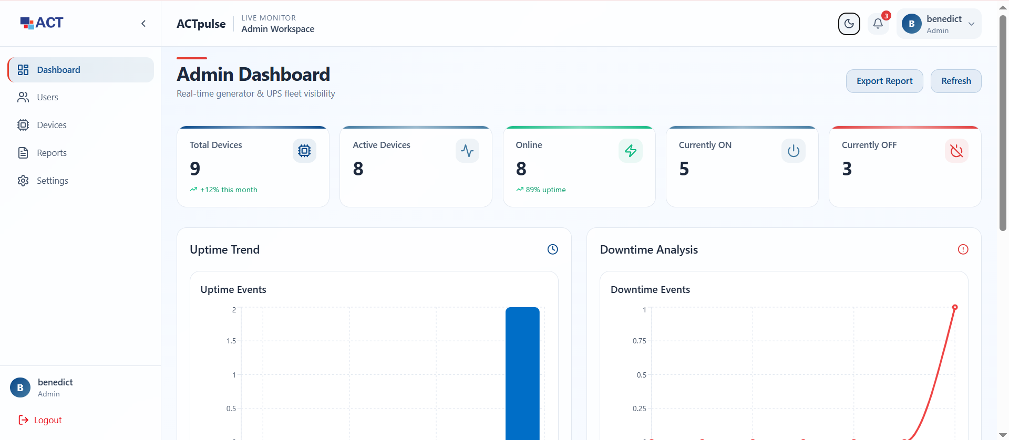

Backend
- Nest.js
- Responsible for:
  - Real-time data ingestion
  - WebSocket-based updates to the frontend
  - Consumption of device messages via MQTT
  - Storage and processing of device state events

Embedded Firmware
- Arduino Framework
- Used to develop firmware for the microcontroller
- Provides rapid development, strong community support, and long-term maintainability

Controller Hardware
- ESP32 Microcontroller
- Key characteristics:
  - Integrated Wi-Fi connectivity
  - Sufficient processing capability for sensor data acquisition
  - Multiple ADC and GPIO interfaces
  - Wide industry adoption and strong supply availability
The ESP32 acts as the edge controller, interfacing with electrical sensors, determining device state, and transmitting state changes to the backend system over the network.
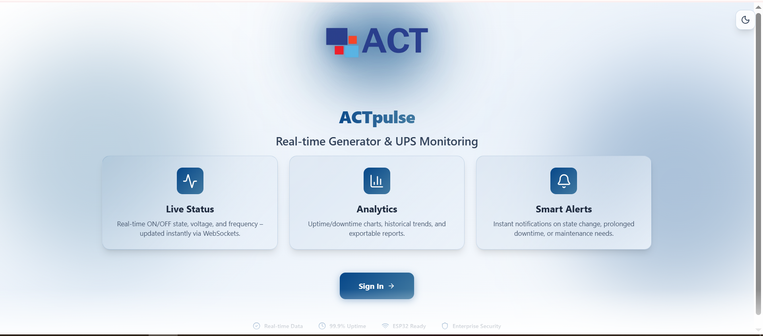

Chapter 2 – Hardware Architecture & Design Approach

2.1 Hardware Design Philosophy
The hardware architecture of the ActPulse IoT system is designed to prioritize electrical safety, operational reliability, simplicity of implementation, and long-term maintainability, while remaining flexible enough to support future functional expansion.
The system is intentionally designed for binary operational state detection (ON/OFF) rather than complex electrical measurement, ensuring ease of deployment and reduced risk, especially in environments involving high-voltage power equipment such as generators and UPS systems.
The following principles guide all hardware and architectural decisions.

Electrical Safety
The system is explicitly designed to minimize direct interaction with high-voltage AC power lines and to ensure that all low-voltage electronics remain electrically isolated from mains voltage wherever possible.
Key safety objectives include:
- Electrical separation between high-voltage AC circuits and low-voltage DC electronics
- Reduced risk during installation, operation, and maintenance
- Protection of the microcontroller from electrical surges and faults
This approach significantly reduces hazards to personnel and prevents damage to sensitive control electronics.

Modular and Replaceable Components
The hardware architecture follows a modular design approach, where each functional block operates independently and can be replaced without impacting the rest of the system.
Major functional blocks include:
- Controller module (ESP32)
- Power detection module (relay and voltage sensor)
- Power supply module (battery, charger, boost converter)
This modularity enables:
- Easy replacement of faulty components
- Flexibility in sourcing components from different vendors
- Incremental upgrades without a full system redesign
Widely available, non-proprietary modules are preferred to ensure longevity and maintainability.

Industry-Proven Detection Components
Only widely adopted and field-tested components are used in the system design. This ensures:
- Predictable behavior during continuous operation
- Availability of technical documentation and community support
- Reduced integration and commissioning risk
The project avoids experimental or niche sensing techniques in favor of simple, proven electromechanical and voltage-detection methods commonly used in industrial and building automation systems.

Readily Available Components
All hardware components are selected based on:
- Availability from multiple suppliers
- Suitability for the 220–240V AC electrical standard
- Long-term production viability
This reduces supply-chain risk and ensures that replacement parts remain available throughout the system lifecycle.

2.2 Power Detection Methodology

Rationale for Voltage-Based Operational Detection
The primary objective of the ActPulse hardware is to determine whether a monitored device (generator or UPS) is operational (ON) or non-operational (OFF). Precise electrical measurements such as voltage level, current magnitude, or power consumption are out of scope for Phase One.
Voltage presence was selected as the most appropriate indicator of operational state based on the following considerations:
- The presence of output voltage directly correlates with generator or UPS operation
- Voltage detection allows clear binary ON/OFF interpretation
- The approach is simple, reliable, and cost-effective
- It minimizes firmware complexity and calibration requirements

Relay-Based ON / OFF Detection (Primary Method)
An AC electromechanical relay with a 220–240V AC coil is used as the primary ON/OFF detection mechanism.
Operation principle:
- When output voltage is present, the relay coil is energized
- Relay contacts change state (COM → NO closed)
- The ESP32 reads a clean digital HIGH signal
- When voltage is absent, the relay de-energizes and the signal returns LOW
This method provides:
- Clear and noise-free digital signaling
- Electrical isolation between AC and DC domains
- High reliability and long-term stability

Voltage Sensor Module (Secondary / Redundant Detection)
In addition to the relay, an AC voltage sensor module is included in the design to:
- Confirm voltage presence independently
- Enable future expansion (e.g., voltage quality checks)
- Provide redundancy for diagnostics and validation
The voltage sensor output can be read either:
- As a digital presence signal, or
- As an analog value (if required in future phases)
In Phase One, the voltage sensor is used only to detect voltage presence, not to perform quantitative voltage measurement.

Event-Driven Reporting (State Change Only)
To optimize bandwidth usage and system efficiency, the hardware reports only state transitions, not continuous readings.
- OFF → ON generates an event
- ON → OFF generates an event
- No data is transmitted while the state remains unchanged
This approach:
- Reduces network traffic
- Lowers power consumption
- Produces a clean and accurate event log for uptime/downtime calculations

2.3 Hardware Signal Flow

Signal Flow Overview
The overall signal flow follows a clear and robust sequence:
Electrical Device → Detection Components → ESP32 Controller → Network Backend
Each stage is logically and electrically separated to ensure safe and reliable operation.

Physical Isolation Between AC Mains and Microcontroller
Electrical isolation is achieved through:
- Electromechanical relay contacts
- Isolated voltage sensor modules
As a result:
- The ESP32 never interfaces directly with high-voltage AC lines
- All inputs to the controller are low-voltage digital or analog signals
- Electrical faults on the AC side are unlikely to propagate to the controller

Low-Voltage Operation on Controller Side
All controller-side electronics operate at safe low-voltage levels (3.3V–5V DC), including:
- ESP32 logic
- Sensor outputs
- Battery-backed power circuitry
Benefits include:
- Compatibility with microcontroller input specifications
- Reduced thermal and electrical stress
- Improved safety during installation and servicing

2.4 Controller Selection Rationale

ESP32 Selection Overview
The ESP32 microcontroller is selected as the central controller due to its strong suitability for network-connected, event-driven IoT monitoring systems.

Wi-Fi Connectivity
- Integrated Wi-Fi eliminates the need for external communication modules
- Enables direct connectivity to local or internet networks
- Supports low-latency, real-time data transmission

Arduino Framework Compatibility
- Mature and widely supported development ecosystem
- Extensive library availability
- Reduced firmware development and maintenance effort
- Simplified onboarding for developers and technicians

GPIO and ADC Capabilities
The ESP32 provides:
- Multiple GPIO pins for digital relay and sensor inputs
- ADC channels for voltage sensor integration
- Sufficient processing capability for state evaluation and event handling
This makes the ESP32 well-suited for both current Phase One requirements and future system expansion.

Chapter 3 – System Architecture & Implementation Design

3.1 Overall System Architecture

3.1.1 Architectural Overview
The ActPulse IoT system follows a layered, end-to-end architecture that connects physical electrical equipment to a cloud-based monitoring platform and a web-based frontend interface.
The architecture is composed of four primary layers:
- Monitored Electrical Device Layer
- Edge IoT Hardware Layer
- Backend & Messaging Layer
- Frontend Visualization Layer
Each layer is logically separated and communicates with adjacent layers using clearly defined interfaces. This separation improves system scalability, maintainability, and fault isolation.

3.1.2 End-to-End System Architecture Diagram
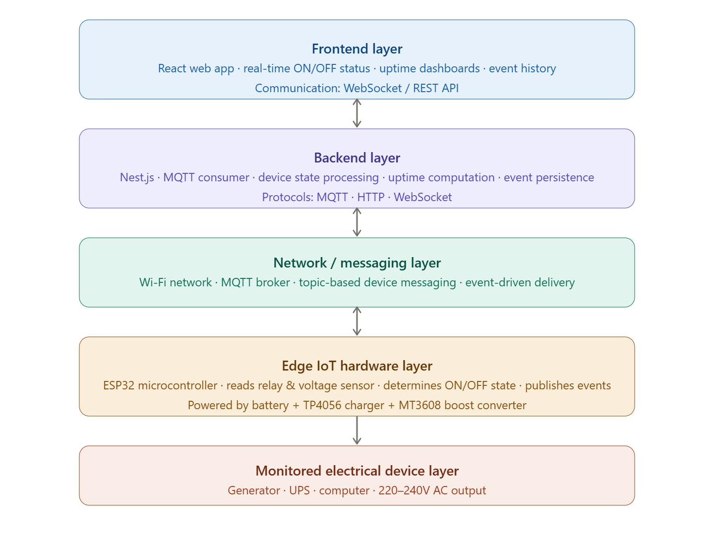

3.1.3 Architectural Characteristics
Event-Driven Communication
The ESP32 transmits data only when a state transition occurs (ON ↔ OFF). This minimizes network usage and ensures clean, meaningful data at the backend.
Loose Coupling Between Layers
No layer depends on the internal implementation of another. For example:
- The frontend does not communicate directly with the ESP32
- The ESP32 does not require knowledge of database structures
Scalability
Multiple ESP32 devices can publish to the same backend using unique device identifiers, allowing the system to scale horizontally without architectural changes.

3.2 Edge IoT Hardware Architecture

3.2.1 Hardware Block-Level Architecture
The IoT hardware unit is built from three primary functional blocks:
- Power Detection Block
- Controller Block
- Power Supply Block
Each block is electrically isolated where necessary and designed for independent operation.
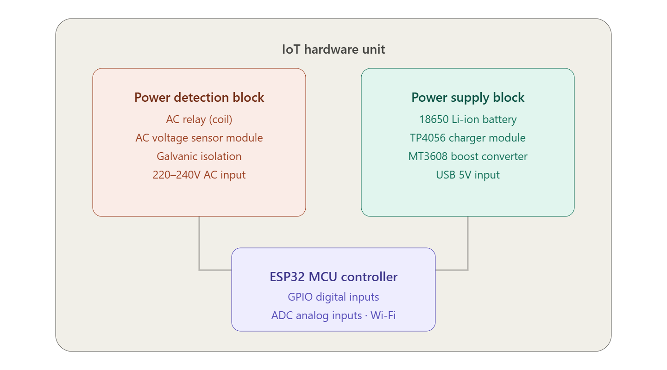

3.2.2 Electrical Isolation Strategy
Electrical isolation is achieved through:
- Relay coil and contacts (AC side isolated from ESP32 GPIO)
- Isolated voltage sensor module
- Low-voltage battery-powered control electronics
This ensures:
- No direct electrical path between AC mains and the ESP32
- Reduced risk of damage from voltage surges
- Safe handling during installation and maintenance

3.3 Detailed IoT Component Connection Diagram

3.3.1 AC Detection and Control Wiring Diagram
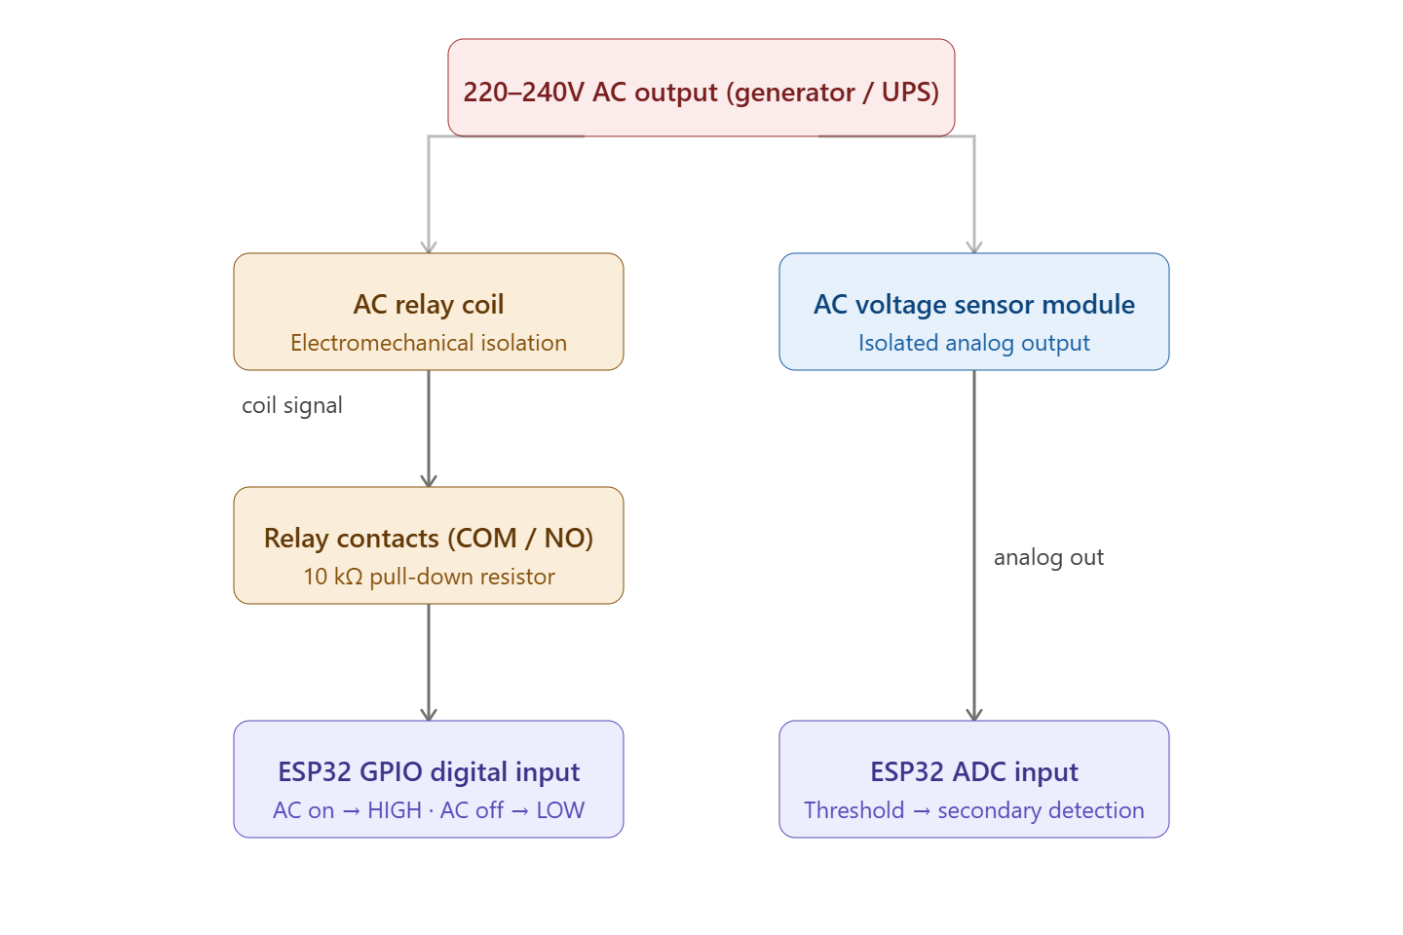Relay Function
- AC present → Relay energized → GPIO reads HIGH
- AC absent → Relay de-energized → GPIO reads LOW
A 10kΩ pull-down resistor ensures stable logic levels when the relay is open.

3.3.2 Voltage Sensor Connection (Secondary Detection)
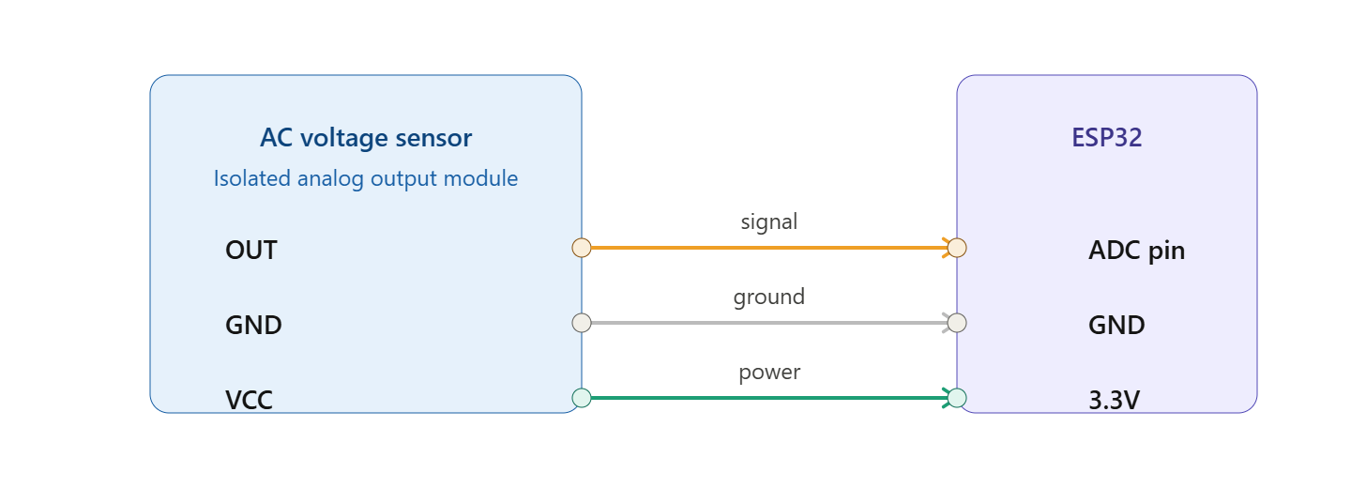
In Phase One, the analog value is thresholded to detect voltage presence only.

3.4 Power Supply Architecture

3.4.1 Battery-Based Power System

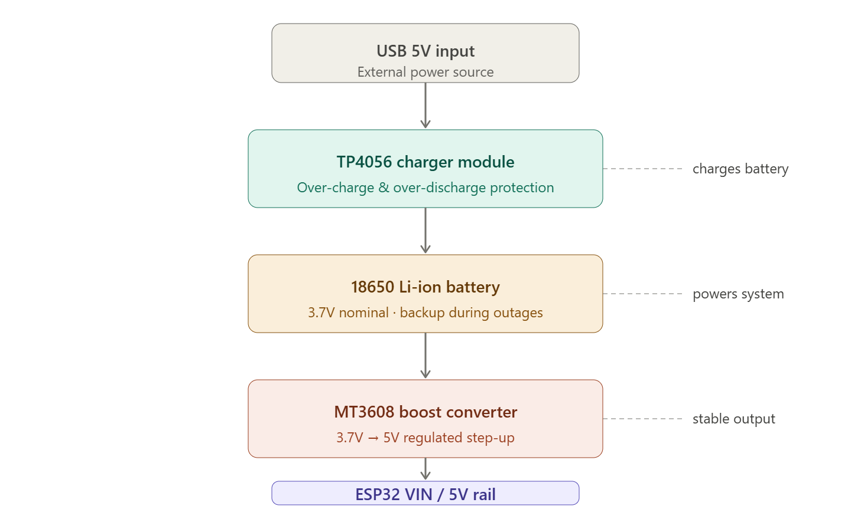

3.4.2 Power Design Rationale
- Battery-backed operation ensures monitoring continuity during power outages
- Boost converter provides stable voltage for ESP32 operation
- TP4056 protection circuitry prevents over-charge and over-discharge
- Enables monitoring of generators and UPS systems even during transitions

3.5 Data Flow and Operational Sequence

3.5.1 ON / OFF Event Flow
- Electrical device turns ON
- AC voltage energizes relay and voltage sensor
- ESP32 detects state change
- ESP32 publishes MQTT event:
- device/{device_id}/state → ON
- Backend records timestamp
- Frontend updates status in real time
The reverse sequence occurs for OFF events.

3.6 Summary
This chapter defined the complete system architecture and hardware implementation design of the ActPulse IoT monitoring system. The architecture demonstrates:
- Safe and isolated electrical design
- Clear separation between hardware, backend, and frontend layers
- Event-driven communication optimized for reliability and efficiency
- A modular IoT hardware platform suitable for scalable deployment
This architectural foundation ensures that the system meets its core objectives of reliable ON/OFF detection, real-time visibility, and long-term operational analytics.

3.7 – Comprehensive Electronic Circuit Design

3.7.1 Circuit Design Overview
The ActPulse IoT electronic circuit is composed of three electrically distinct domains:
- High-Voltage AC Domain (220–240V AC)
Used only for voltage presence detection
→ Fully isolated from low-voltage electronics
- Low-Voltage DC Control Domain (3.3V / 5V DC)
ESP32, sensors, logic signals
- Battery Power Domain (3.7V–5V DC)
Provides uninterrupted power to the controller
Electrical isolation between domains ensures operational safety and system reliability.

3.7.2 ESP32 Pin Assignment Summary
Function | ESP32 Pin | Pin Type
Relay contact input | GPIO 18 | Digital Input
Voltage sensor output | GPIO 34 | ADC Input
Status LED (optional) | GPIO 2 | Digital Output
Power input | VIN | 5V Input
Ground | GND | Ground
GPIO 34 is input-only, making it ideal for analog sensing.

3.7.3 High-Voltage AC Detection Circuit

A. AC Relay Coil Wiring (220–240V AC)
Purpose: Convert AC voltage presence into an isolated digital signal.
GENERATOR / UPS OUTPUT (220–240V AC)

Live (L) --------------------+------------------+
| |
[ Relay Coil ] [ AC Voltage Sensor ]
| |
Neutral (N) -------------------+------------------+
✔ Relay coil rated 220–240V AC
✔ Voltage sensor module is galvanically isolated

B. Relay Contact → ESP32 Digital Input
Relay Contacts Used:
- COM (Common)
- NO (Normally Open)
ESP32 SIDE (Low Voltage)

ESP32 3.3V ----+--------------------------+
| |
[ Relay COM ] |
|
[ Relay NO ] ---- GPIO 18 ----+
|
[10kΩ]
|
GND

Electrical Behavior
AC State | Relay Coil | NO Contact | GPIO 18
OFF | De-energized | Open | LOW
ON | Energized | Closed | HIGH
10kΩ resistor acts as a pull-down to ensure a stable LOW when relay is open.

3.7.4 AC Voltage Sensor → ESP32 ADC Circuit

Voltage Sensor Connections
Voltage Sensor Pin | Connects To
VCC | ESP32 3.3V
GND | ESP32 GND
OUT | ESP32 GPIO 34 (ADC1_CH6)

+-------------------------+
| AC Voltage Sensor |
| |
| VCC ---- ESP32 3.3V |
| GND ---- ESP32 GND |
| OUT ---- GPIO 34 |
+-------------------------+
Firmware applies a simple threshold to determine voltage presence.

3.7.5 Battery Power Supply Circuit

A. TP4056 Battery Charging Module
TP4056 Pin | Connection
B+ | 18650 Battery Positive
B− | 18650 Battery Negative
OUT+ | MT3608 VIN+
OUT− | MT3608 GND
IN+ | USB 5V
IN− | USB GND

USB 5V
|
+--v------+
| TP4056 |
| |
| B+ ---> 18650 +
| B- ---> 18650 -
| OUT+ --> MT3608 VIN+
| OUT- --> MT3608 GND
+---------+
✔ Module includes overcharge & over-discharge protection

B. MT3608 Boost Converter (3.7V → 5V)
MT3608 Pin | Connection
VIN+ | TP4056 OUT+
VIN− | TP4056 OUT−
VOUT+ | ESP32 VIN
VOUT− | ESP32 GND
+----------------+
| MT3608 Boost |
| |
| VIN+ <-- TP4056 OUT+
| VIN- <-- TP4056 OUT-
| VOUT+ --> ESP32 VIN (5V)
| VOUT- --> ESP32 GND
+----------------+
✔ Adjust MT3608 output to 5.0V before connecting ESP32

3.7.6 Common Ground Strategy (Low Voltage Only)
ESP32 GND
|
+---- Voltage Sensor GND
|
+---- TP4056 OUT-
|
+---- MT3608 VOUT-
|
+---- Pull-down Resistor GND
⚠ IMPORTANT:
- AC Neutral must never connect to ESP32 GND
- Isolation is maintained strictly via relay & sensor modules

3.7.7 Optional Status LED Circuit
ESP32 GPIO 2 ----[330Ω]----|>|---- GND
LED State | Meaning
ON | Device powered
Blinking | Wi-Fi / MQTT activity

3.7.8 Complete Text-Based Circuit Diagram

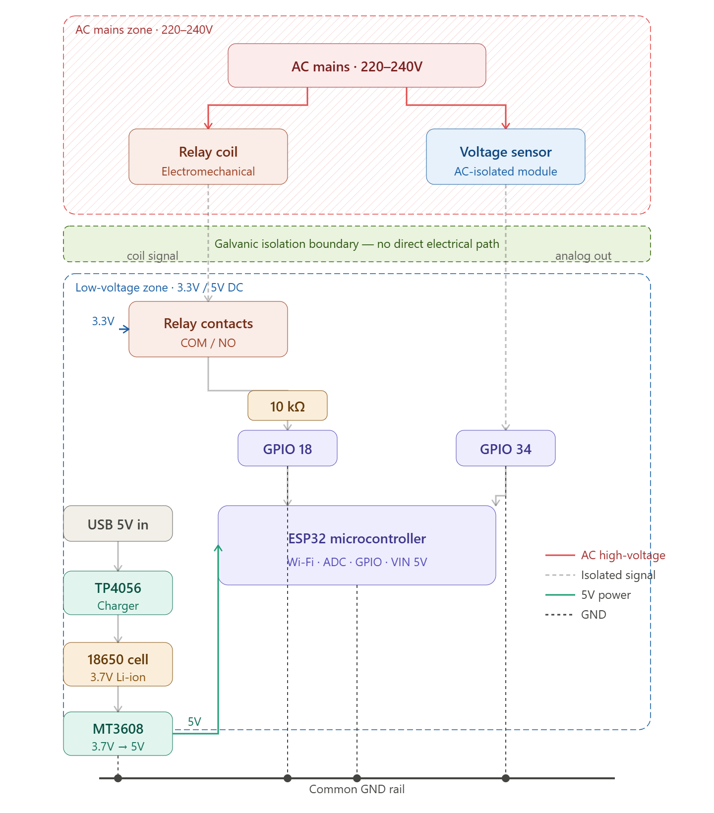

3.7.9 Safety and Implementation Notes (Very Important)
✔ Use proper insulated terminal blocks for AC wiring
✔ House AC components in separate compartment inside enclosure
✔ Add heat-shrink tubing on all exposed AC joints
✔ Never test AC side on a breadboard
✔ Verify isolation using a multimeter before powering ESP32

3.7.10 Circuit Design Summary
This electronic circuit design:
- Safely detects AC voltage presence
- Maintains full galvanic isolation
- Provides battery-backed operation
- Produces clean digital & analog signals
- Fully aligns with ESP32 electrical limits
- Is scalable, maintainable, and field-ready

